**UE20CS254: Operating System**

**Assignments (Week 1 - Week 5)**

**Name: Vishwa Mehul Mehta**

**SRN: PES2UG20CS389**

**Section: F**

**Week 1:**

**Code:**

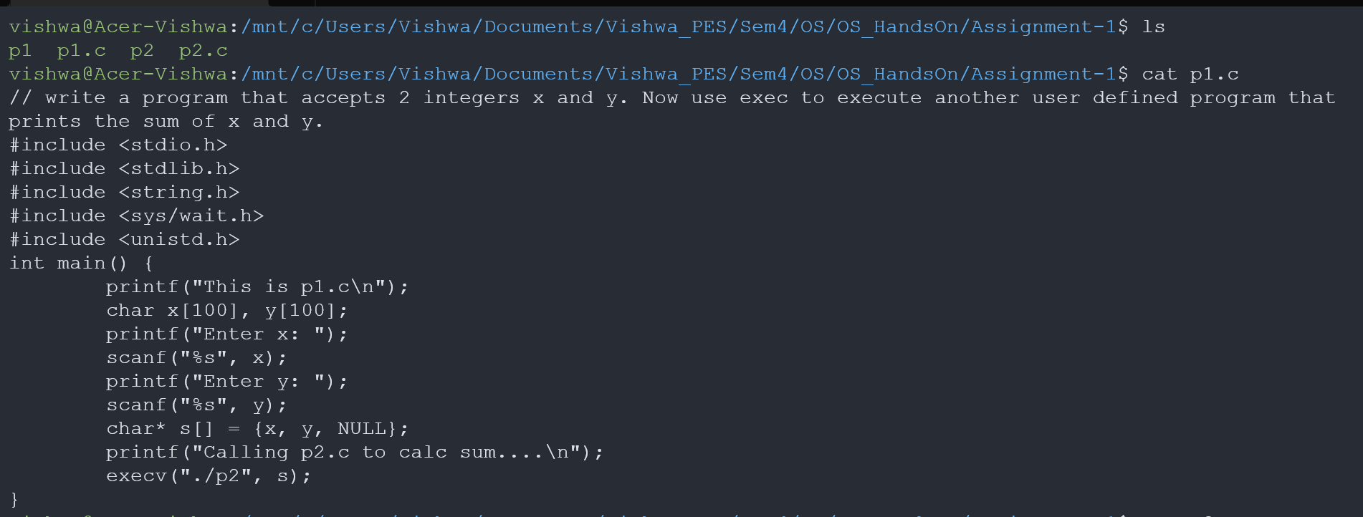 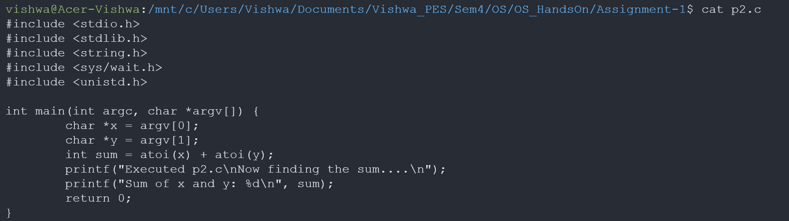

**Output Screenshots:**

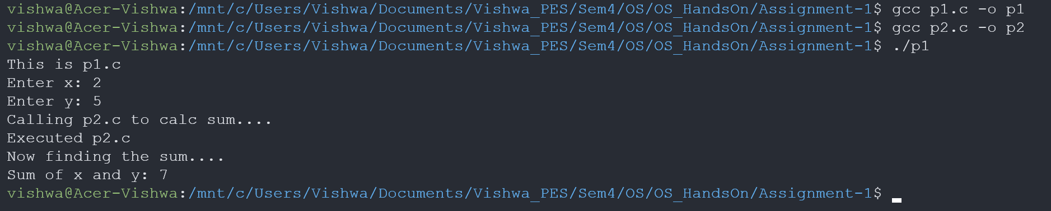

**Week 2:**

**Code:**

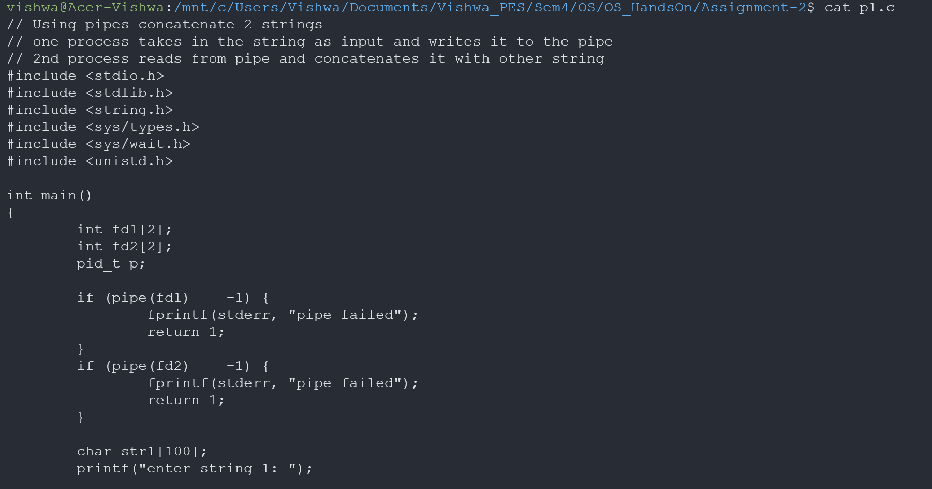

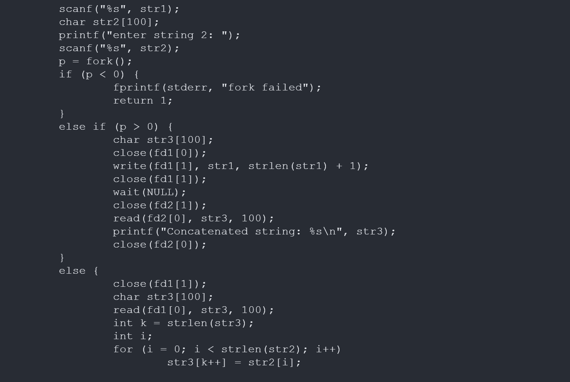

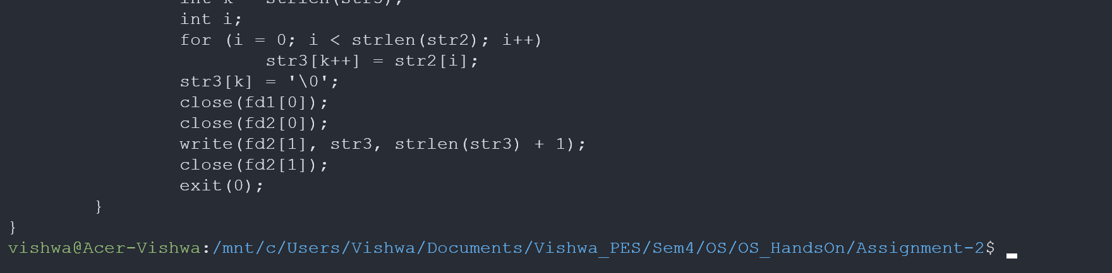

**Output Screenshots:**

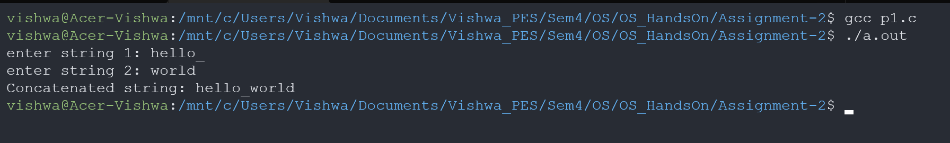

**Week 3:**

**Code:**

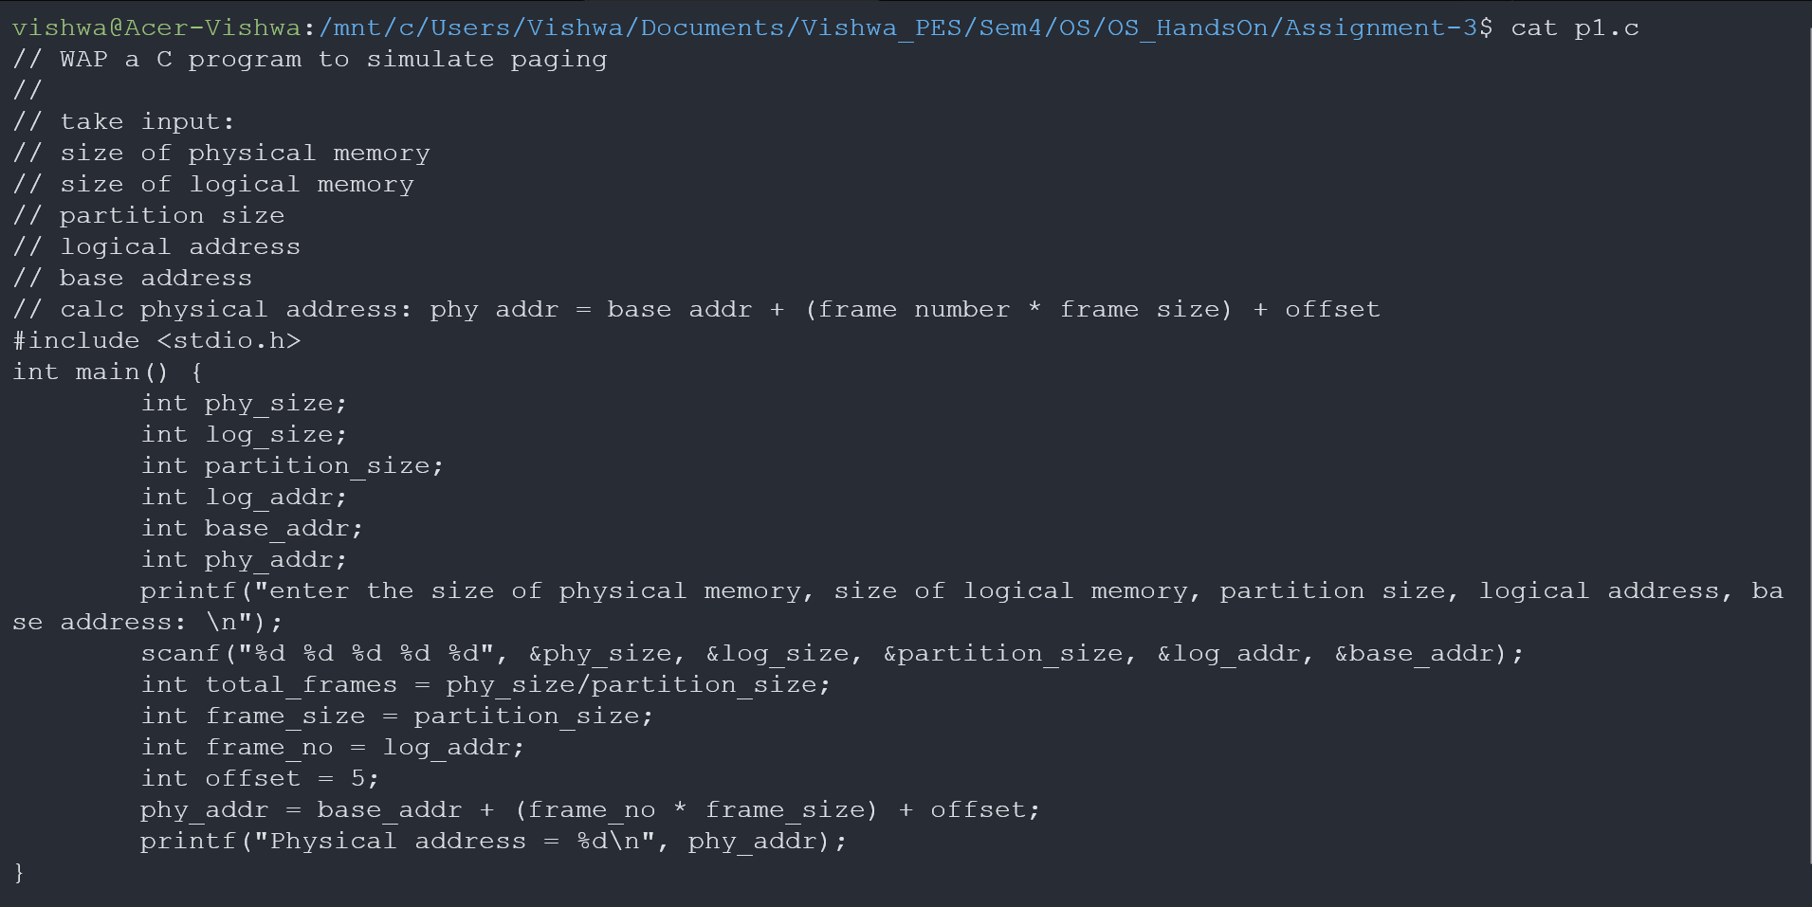

**Output Screenshots:**

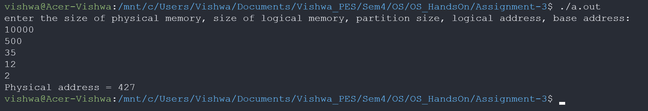

**Week 4:**

**Code:**

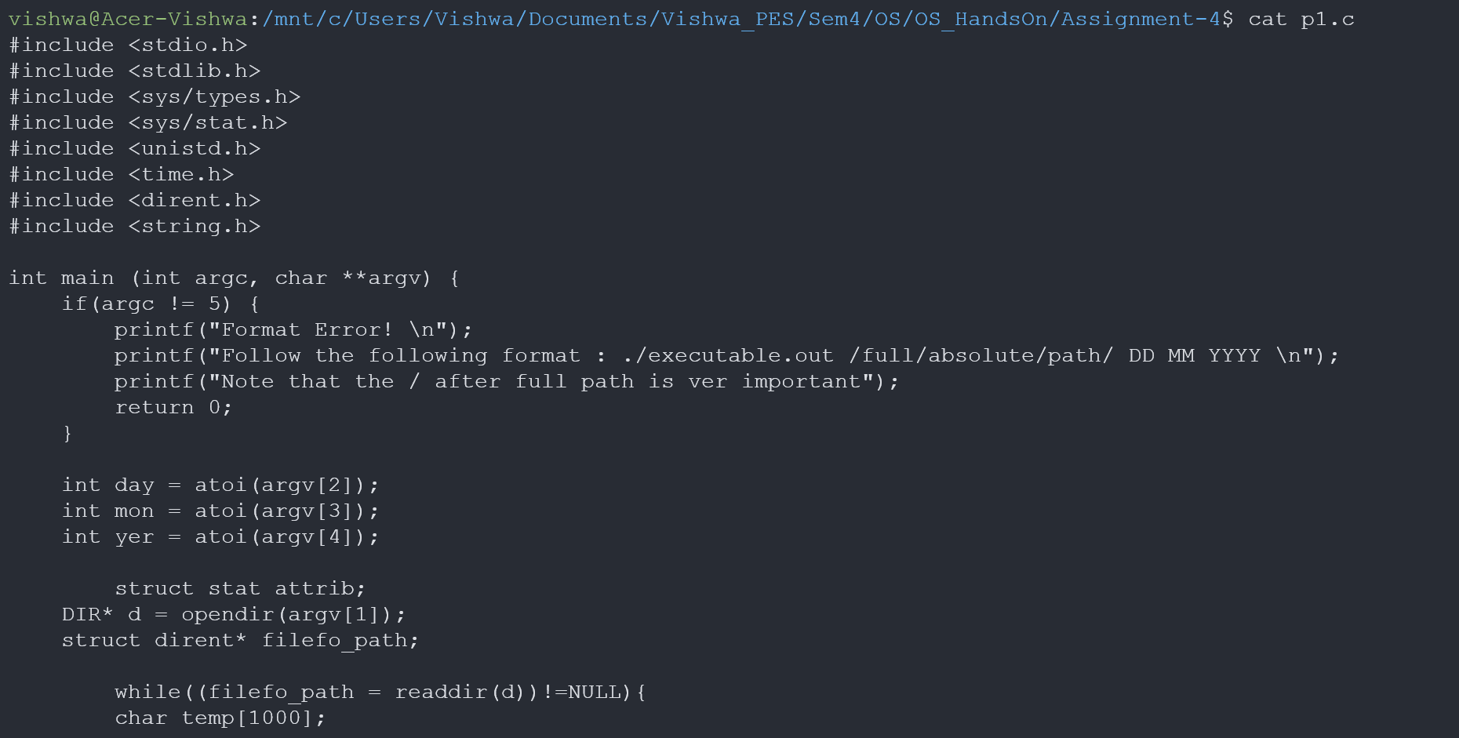

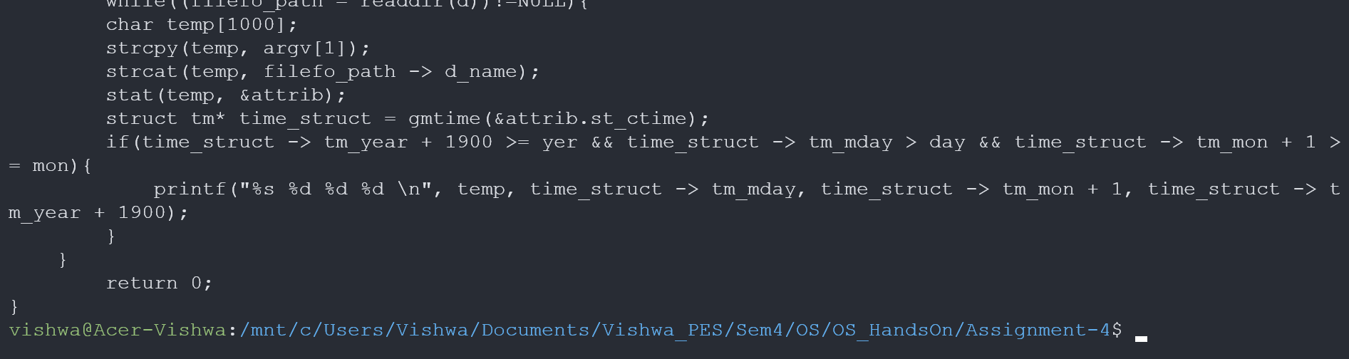

**Output Screenshots:**

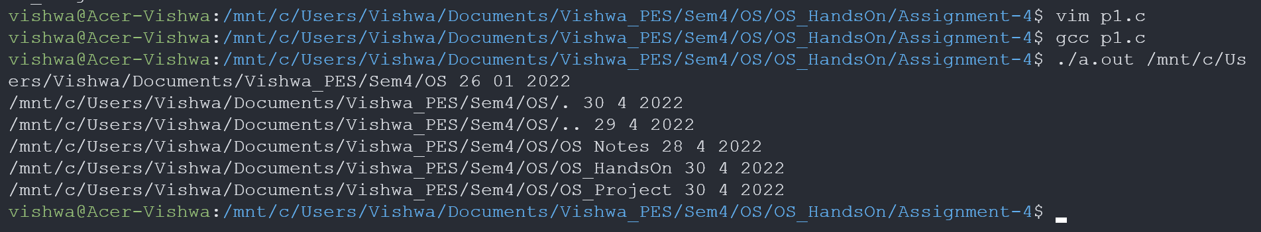

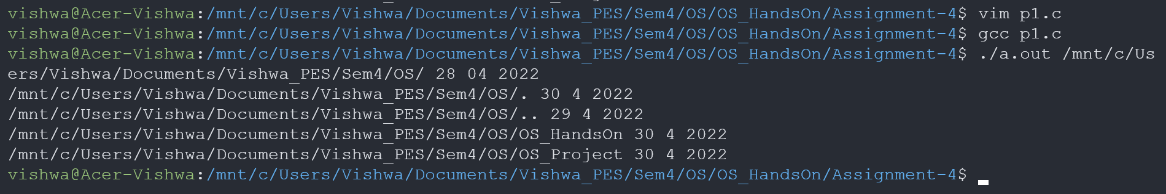

**Week 5:**

**Code:**

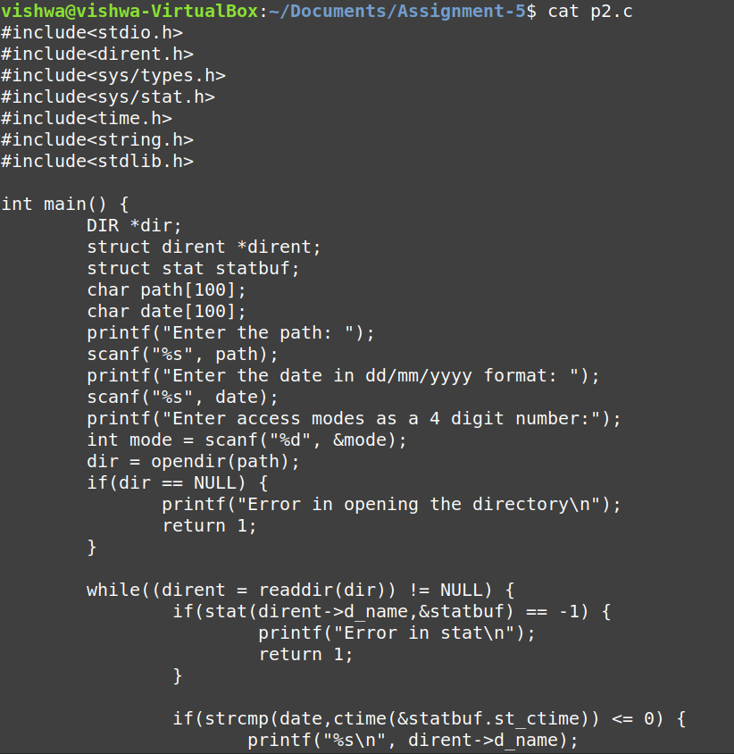

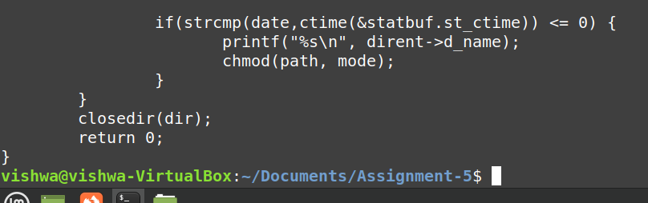

**Output Screenshots:**

